REM FASHION EXPLORATION

Tuesday
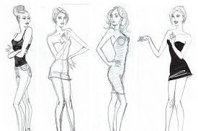

You will learn to use fashion illustration croquis drawsing or schematics to depict fashion ideas for clothing design. Using pencils, pencil crayons, paper and markers, you will learn how to draw different types of fabric and design details!

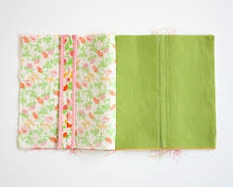
Let’s get sewing! Beginners will learn the basics of the sewing machine and some simple, seam construction as well as seam finishes to get you going on your project. You will use a sewing machine, a serger, cutting mats and rotary cutters to begin your seam sample book, that you will take home with you. Once you feel comfortable with the machines, and if time permits, you .will make a simple pillow case, using three prints of cotton.

Wednesday, Thursday, and Friday Morning

Students will have the choice of working on either of the following projects:

(1) First Nation Grad Dress Design or First Nation Vest/Shawl Design
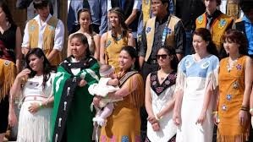
The focus of this session is to take measurements, to determine the pattern size and shape that best works with your figure, to design ideas, and to begin the cutting, sewing and fitting process. Vests and shawls could be completed by the end of the week. Dresses might not be finished by the end of REM, but the intent is to give you enough information and develop your skills so that you can complete your project before graduation. Students wanting to work with hide should note that the sewing machines will only go through deer hide or split elk/cow. Students are responsible for supplying their own hide. We will work with local First Nations to sponsor these purchases

(2) The Pullover Hoodie

A Unisex pattern will be used to help you make a pull-over hoodie. You can customize your look with appliqué techniques that you will learn. Bring you own awesome designs for appliqué or leave it clean and simple.

